**ACTIVITY-3**

**AWARENESS PROGRAM ON COWIN APP**

**Activity Details:**

|  |  |  |
| --- | --- | --- |
| **Activity Head** | : | Awareness program on COWIN app |
| **Total Duration Spent** | : | 2 Weeks |
| **Activity Place** | : | Mysuru |

**ACTIVITY SUMMARY:**

**Justification for selected activity**

* The COVID-19 pandemic has led to a dramatic loss of human life worldwide and presents an unprecedented challenge to public health, food systems and the world of work.
* One critical enabler of India’s progress is a digital platform called CoWIN (Winning Over Covid-19), developed by the government. It is a cloud-based system that facilitates registration, immunizations and appointments, and issues digital vaccine certificates.
* India’s Ministry of Health and Family Welfare began digitizing the vaccine supply-chain network through the use of mobile technology. This digital platform is called the Electronic Vaccine Intelligence Network (eVIN) and was set up with initial funding support from Gavi, the Vaccine Alliance.
* CoWIN reflects the citizen-centric design of India’s vaccination program. The portal has a simple user interface for beneficiaries to register and select a convenient facility, with an option to choose the vaccine type. They get a digital vaccine certificate delivered in a QR-code format via a text message, or a printed copy at the facility.
* Vaccinators use the app to verify registered beneficiaries, enter the vaccine doses given and record any adverse events following immunization. People who do not have access to the Internet or an identity card can walk into any health facility and get themselves registered on CoWIN.
* CoWIN is a powerful example of how digital technologies can be used to scale public health programs, and reflects the strides India continues to take in the use of digital technology for scaling public services.

**2. Planning/Approach for 80 hours**

* Started to gather information about Cowin.
* Learnt about the COWIN app completely.
* Learnt how to register in the app and the details to be provided during the registration.
* Practically used the website and understood its operation and the requirements for the registration purpose.
* Shortlisted the places to be visited to give awareness about the app.
* Visited some of the places where people had no knowledge about the app.
* Started creating awareness about Cowin to the people.
* Taught people about the app and the registration process.
* The advantages about the app were thought.
* Manoeuvre to parents, friends and family members.

1. **Weekly wise Report:**

**Week-1**

* Week-1 Day-1: Collected the information about the COWIN app.
* Week-1 Day-2: Learnt about the app details and the registration process to be carried out.
* Week-1 Day-3: Practically used the website and understood its process and the requirements for the registration purpose.
* Week-1 Day-4: Gathered some of the places where we could teach about the app.
* Week-1 Day-5: Shortlisted some of the places where we could visit and teach people about the program.
* Week-1 Day-6: Prepared ourselves how to teach people about the COWIN app and learnt about complications that could occur if they don’t use COWIN app and how serious Covid disease.
* Week-1 Day-7: Decided the place to be visited and how to teach people about the app. Divided the work among ourselves and each person learnt how to teach people about the app.

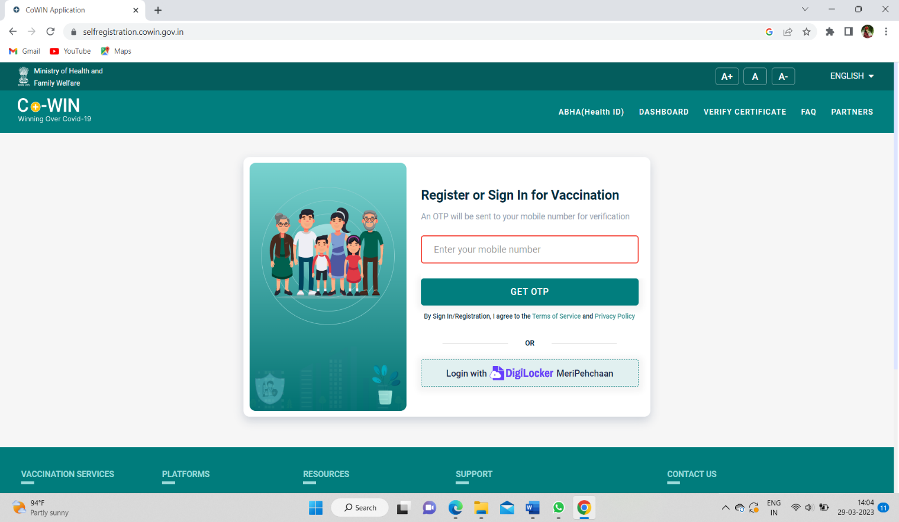

Fig: Registration page

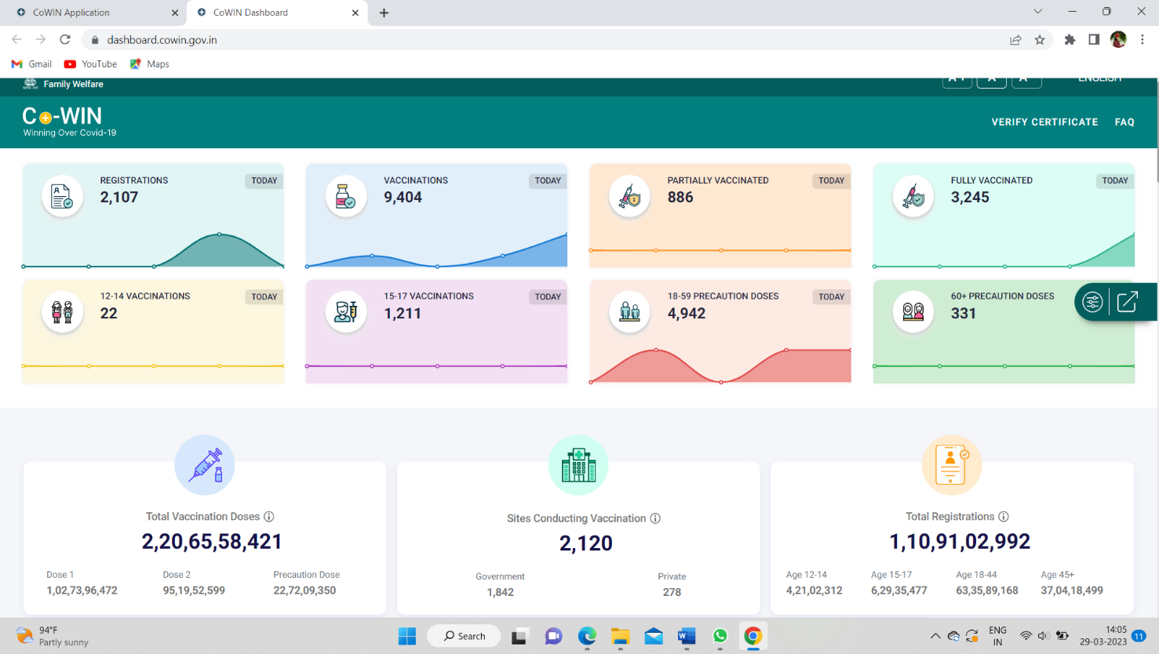

Fig : Options provided in the app

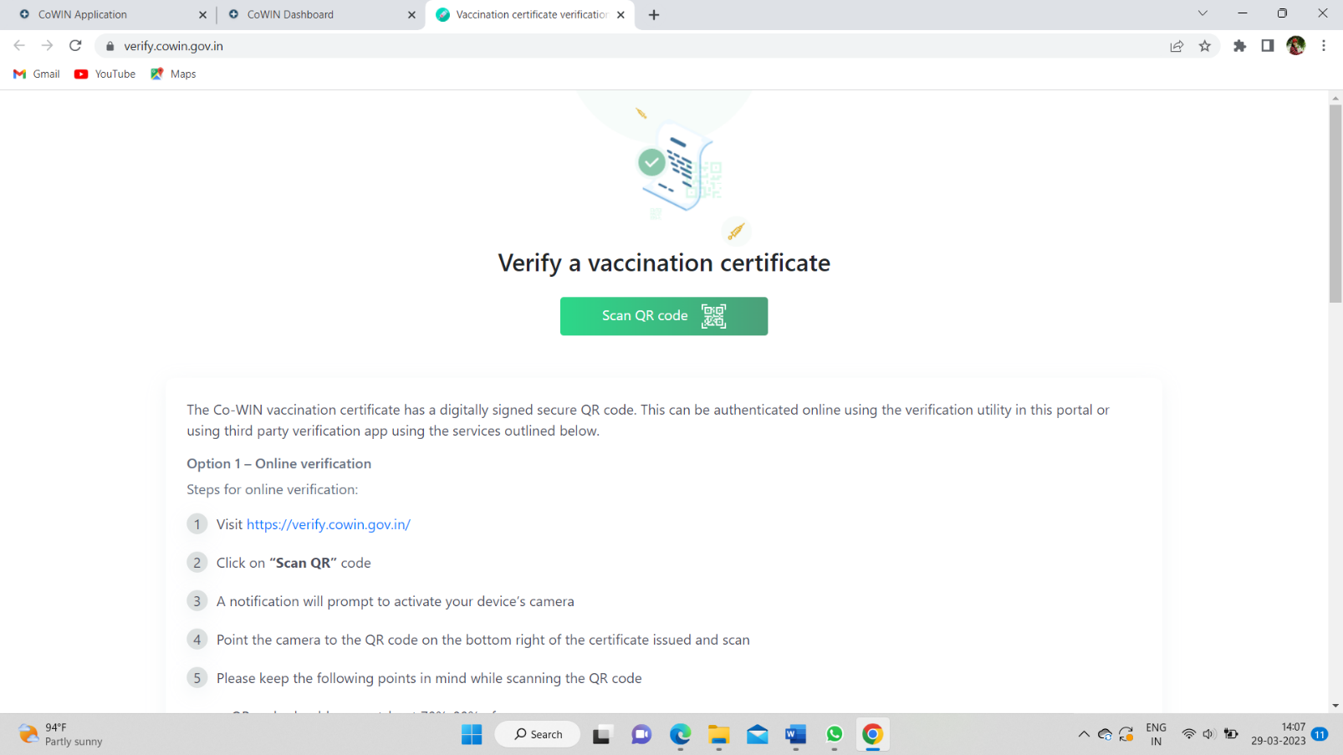

Fig: Vaccination certificate download

**Week-2**

* Week-2 Day-1: Visited the shortlisted places to teach them about the COWIN app.
* Week-2 Day-2: Works were divided among ourselves and all gathered information about the particular fields.
* Week-2 Day-3: Reached people about the COWIN app.
* Week-2 Day-4: People were thought about the app, how to register themselves and the details to be provided during registration.
* Week-2 Day-5: The registration steps were completely thought to the people.
* Week-2 Day-6: Once the registration was successful, they were thought how to use the app and the benefits about the app. How much important the COWIN app is and how to make use of the app was thought.
* Week-2 Day-7: How people can get every detail about the disease and the covid certificates were also thought to them.

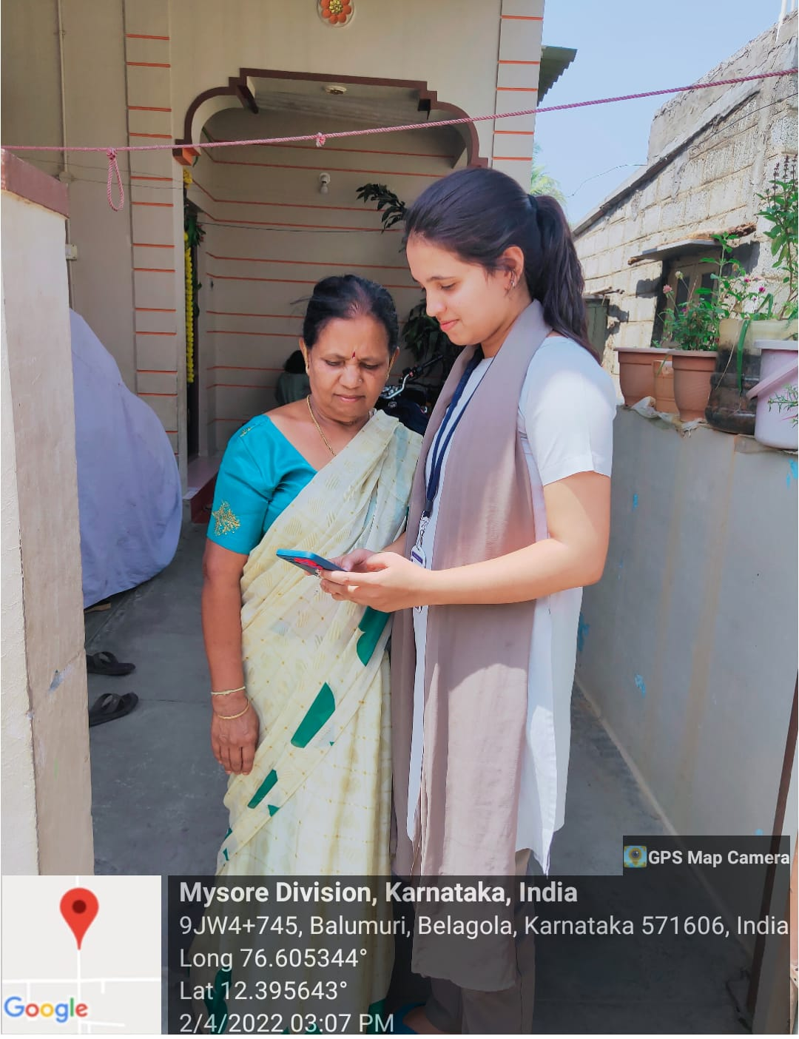

Fig: Teaching about the App

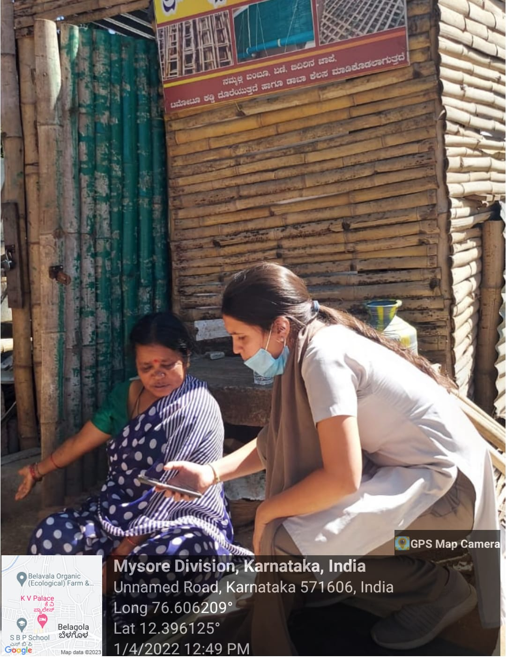

Fig: Demonstrating the App

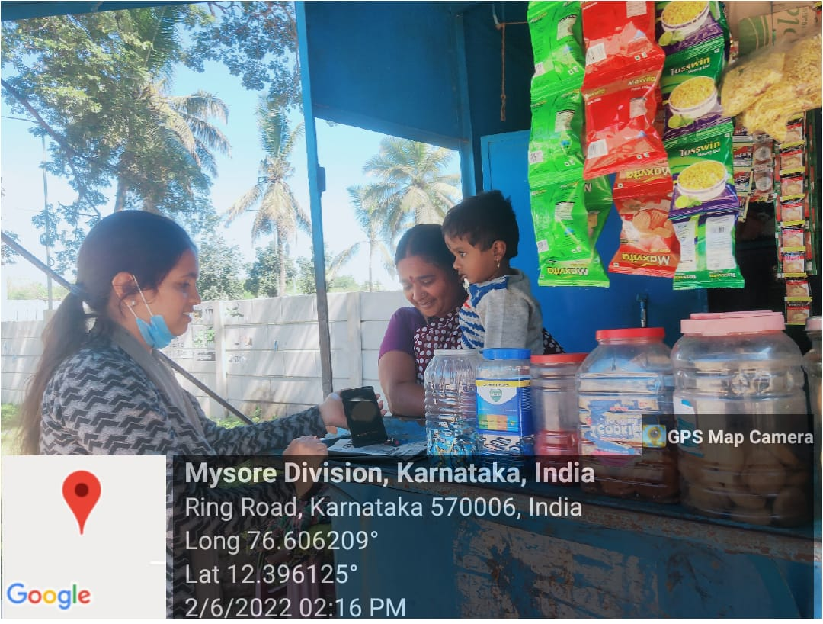

Fig: vaccination certificate awareness

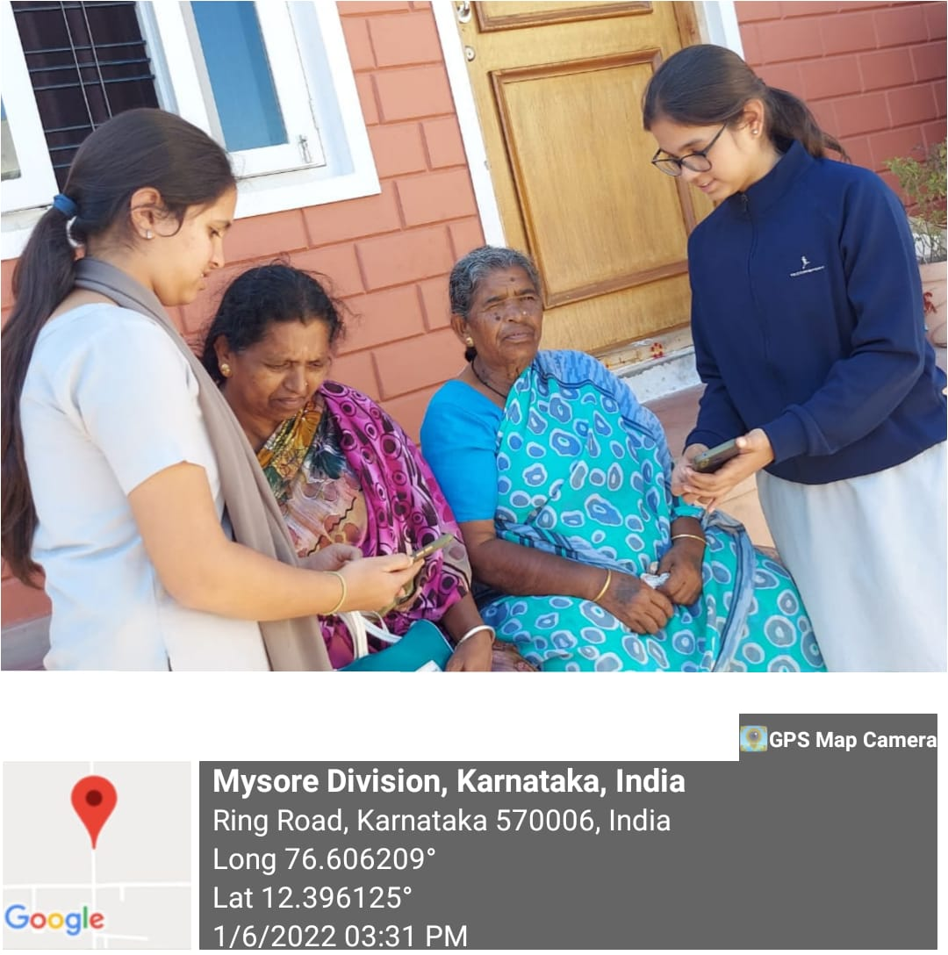

Fig: Educating people about the App with demon

**Activity Experience**

* CoWIN has been developed as a digital platform to support Covid-19 vaccination efforts in India. While most are familiar with the interface for citizens to book vaccination slots, CoWIN also supports multiple other functions. It is part of a sophisticated digital ecosystem, which monitors the vaccine supply chain, the vaccination staff and facilities, and records after-effects of immunization.
* In addition, CoWIN is an important part of a 2019 service delivery ecosystem known as the National Digital Health Ecosystem (NDHE), which facilitates better information flow in the healthcare sector. Various sectors and jurisdictions in India are slowly adopting such digitized, ecosystem approaches to deliver government services to citizens.
* We helped people to know about the CoWIN and explained them how inclusive is the platform was, how it handles citizen's data responsibly, and does it create efficiencies for the citizens. These basic principles were explained by us.
* We also helped them to register to CoWIN which was initially accessible only via digital platform with no assisted or offline substitute.
* We also told them about:

I. Registration Process

II. Health IDs like monitoring of vaccine supply chain and administration Redress mechanism like how the absence of strong accountability mechanisms led to abuses of power in vaccine administration through CoWIN.

**CONCLUSION**

This activity helped provide a new perspective of the world and how the role everybody play sand choices that everyone makes affects it. Change whether small or big can make a difference to a lot. The activities done made me understand that I can also make change by doing simple things, whether it’s by trying to imprint young minds with ideas or cleaning a street. Understanding one’s capabilities is important and the activity has improved my confidence and helped me know that I am a lot more capable. Speaking practically, getting in touch with the society and the problems that dwell in its nook and corners has broadened my knowledge of the world. Organizing the activities pushed me forward to do challenging tasks and have taught me lessons that I will forever use. Working in a team with a group of people is the reason I know that when many hands unite it’s easier to do any task. Moreover, working in a team gave me opportunity to listen to different ideas and creative methods of action. Brainstorming, putting up my own ideas and working together to make an event possible was a process packed with experience.

To conclude, until we take a step forward and out of our comfort zones we cannot grow. These activities helped me grow and make an impact on the outside world. It is the responsibility of the elder generation to guide the younger generation towards making a better world for everyone. Activities such as these helps hasten the process and shape and understand young minds. In many ways these activities also help even adults to look at certain aspects of the world with newer standpoints so that they can also provide a better environment to those around them. Hence, such activities are important as they help everybody learn, grow, change and adapt.